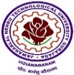

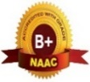

SITAM
SATYA INSTITUTE OF TECHNOLOGY AND MANAGEMENT
Near RTO Office, Gajularega, Vizianagaram-535003, Andhra Pradesh, India
Accredited by "NAAC", Approved by AICTE, New Delhi
(Permanently Affiliated to JNTUGV, Vizianagaram, Recognized by SBTET, Government of A.P)
Email: principal@sitam.co.in, Website: www.sitam.co.in, Face Book: /Sitam.Sgvp, Instagram:/sitamvzm
Telephone No:9676788811, 8978812341/2
EAMCET CODE: SGVP JNTUGV CODE: B6 SBTET CODE: 649

Extension activities in neighborhood communities significantly impact the served communities and the students involved, fostering holistic development and sensitizing students to social issues. For example, under the Integrated Rural People’s Welfare Association (IRPWA), students from various engineering disciplines engage in diverse social activities, creating a profound community impact while gaining invaluable personal growth. Electrical and Electronics Engineering students involved in diverse initiatives—ranging from environmental conservation efforts like tree plantation, to offering support in orphanages and old age homes, and conducting awareness programs in rural areas—students gain firsthand experience of the societal issues that many communities face such as health, hygiene, and education. These activities teach empathy and social responsibility, helping students understand the importance of giving back to society.
Meanwhile, Computer Science Engineering students contributed to digital literacy programs, bridging the digital divide in rural areas. By teaching basic computer skills and internet usage, they empower community members with new tools for education, employment, and communication, enhancing overall quality of life and socio-economic opportunities.
Civil Engineering students have undertaken projects like the community service initiative on rural water supply in Paravathipuram village. By knowing a pumping-based transmission and distribution system, they address the essential need for clean water, improving public health and daily living conditions for villagers. This project also provides students with practical skills and insights into the challenges of infrastructure development in rural settings.
These extension activities have a dual impact: they improve community welfare and foster student development. Students gain real-world experience, develop leadership and teamwork skills, and become more socially aware and responsible citizens. Their involvement often inspires a lifelong commitment to public service and social justice, highlighting the transformative power of integrating community service into educational curricula. Through these experiences, students not only enhance their academic and professional competencies but also cultivate a deep-seated dedication to making a positive difference in society.

SITAM
SATYA INSTITUTE OF TECHNOLOGY AND MANAGEMENT
Near RTO Office, Gajularega, Vizianagaram-535003, Andhra Pradesh, India
Accredited by "NAAC", Approved by AICTE, New Delhi
(Permanently Affiliated to JNTUGV, Vizianagaram, Recognized by SBTET, Government of A.P)
Email: principal@sitam.co.in, Website: www.sitam.co.in, Face Book: /Sitam.Sgvp, Instagram:/sitamvzm
Telephone No:9676788811, 8978812341/2
EAMCET CODE: SGVP JNTUGV CODE: B6 SBTET CODE: 649

Integrated Rural People’s Welfare Association
Integrated Rural People’s Welfare Association (IRPWA) is in action in the state of Andhra Pradesh since 1999. The organisation formed with a group of devoted persons those make every effort for the development of people through IRPWA by reaching at the community level through promotion of their own groups and organizations
IRPWA adopted approach aim at empowering the communities to participate, negotiate, change and hold accountable the institutions that affect their well-being. IRPWA recognizes the needs of the target population and is using enabling steps to address the marginalization of the communities.
Here students are encouraged to participate in number of social activities such as plantation, going to orphans and help them, going to old age homes for service, making the awareness programs in rural areas in so many accepts where the people are lagging behind. Due to this student can know the things really happen in the society and develop mentally and physically according to the situations and challenges in the society. They can make their intelligence and their knowledge in proper way for the development of society.
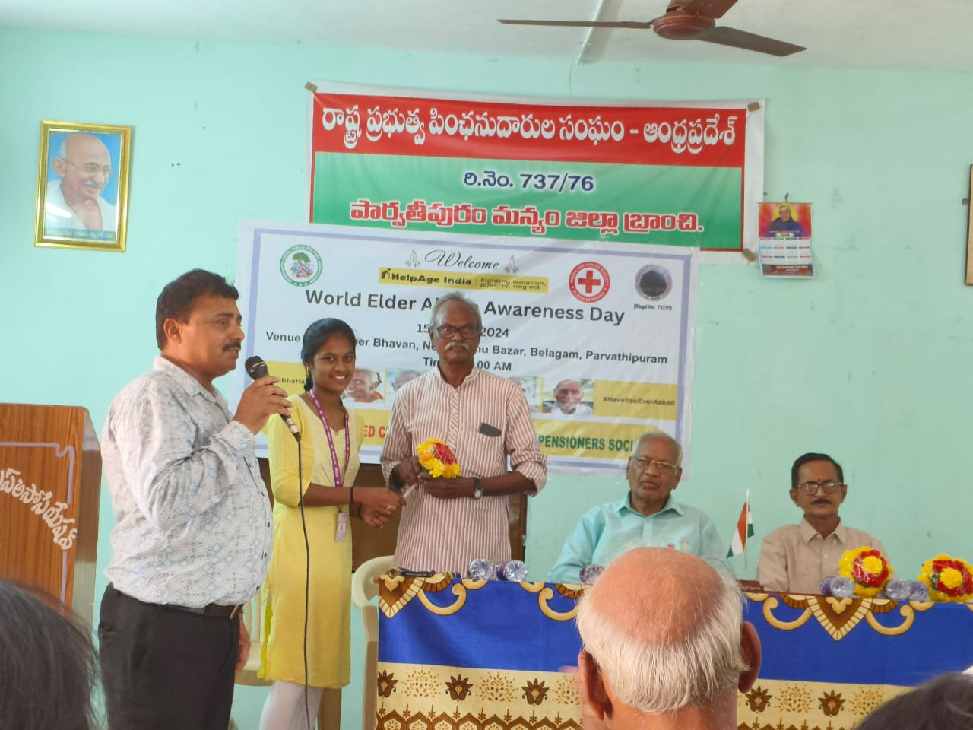
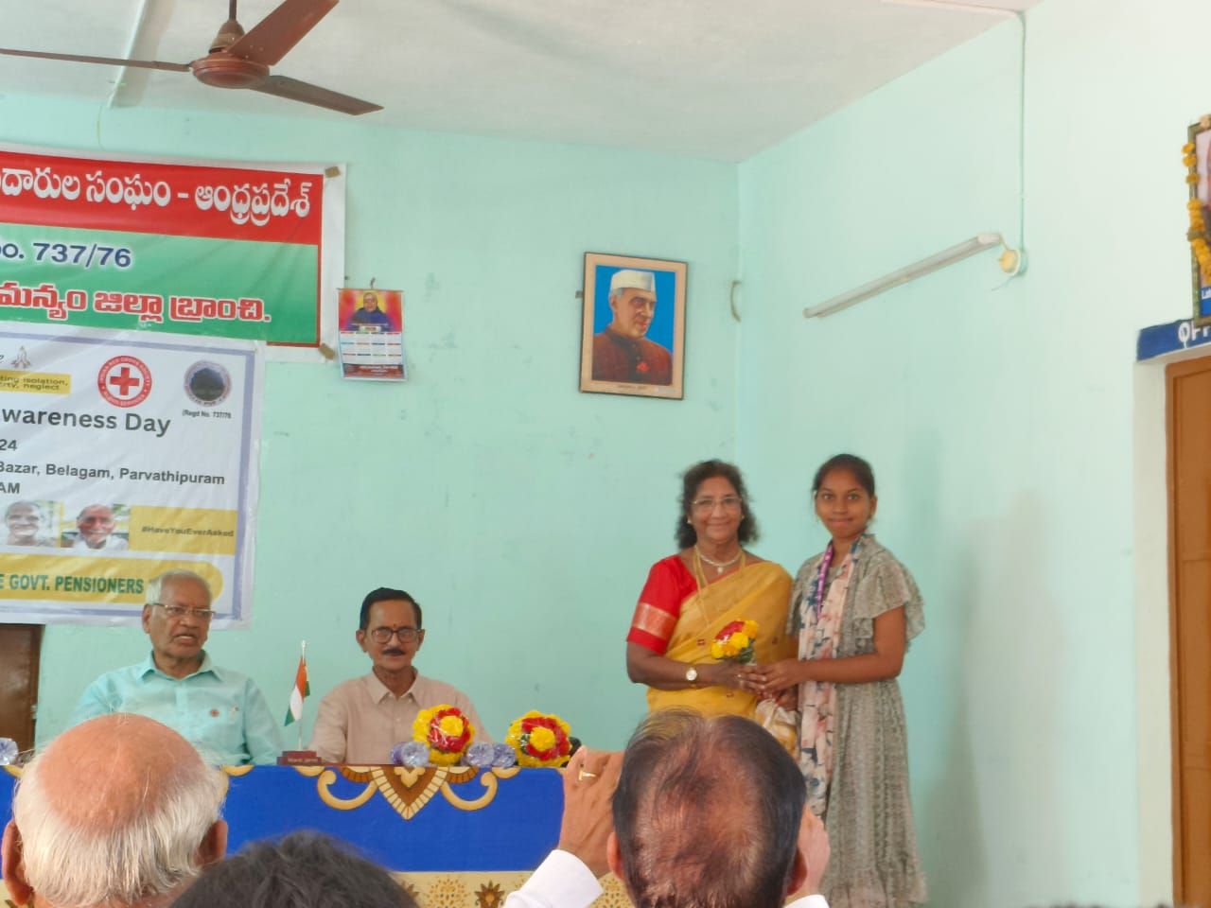
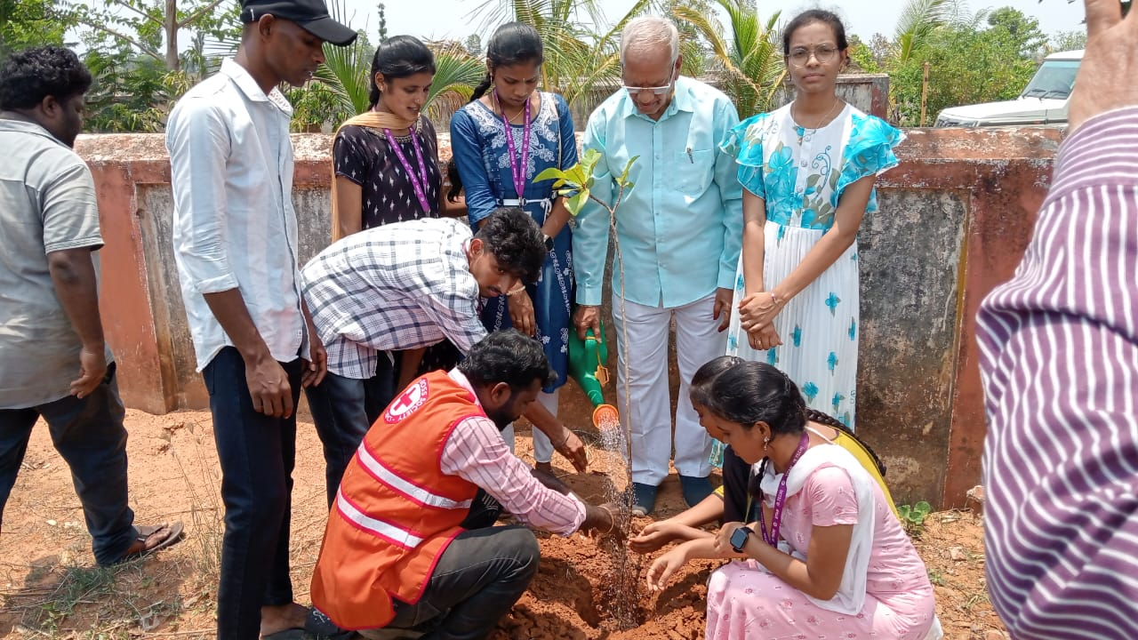
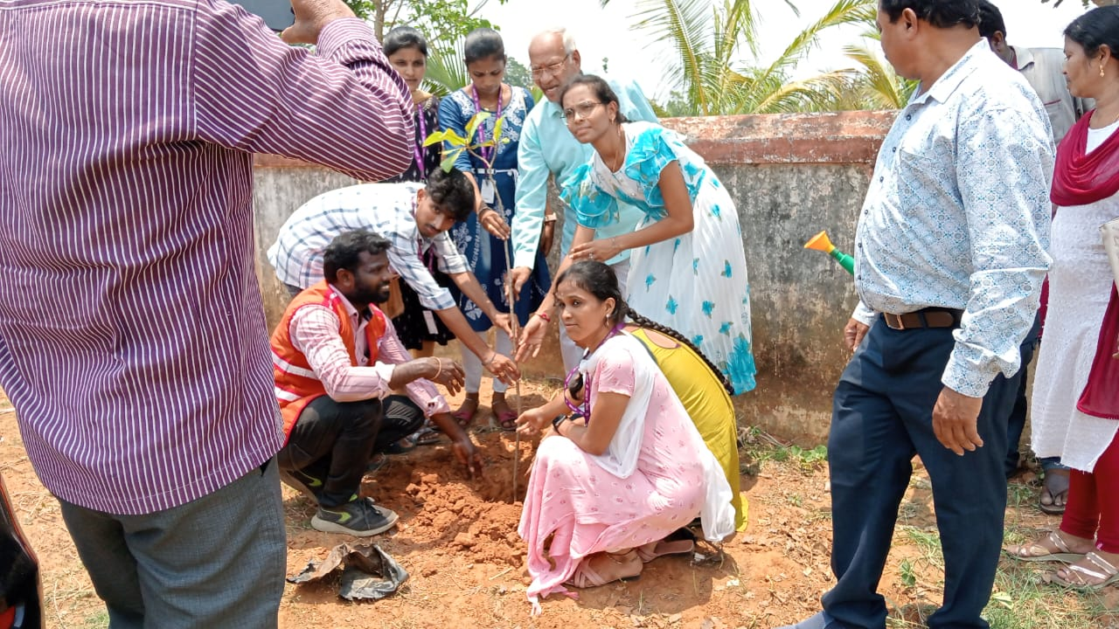

RURAL WATER SUPPLY & SANITATION DEPARTMENT PARVATHIPURAM DIVISION COMMUNITY SERVICE PROJECT
Typical Village/town water supply system constitutes of a gravity/pumping based transmission and distribution system from local/distant water source near dam with needed water treatment system. (local ground/surface water, external piped supply etc.our project is water distribution to the villages. Water will collect a canal after filtration the water and distribution water. •These are (1) surface tanks, (2) surface wells, and (3) tube-wells.are collecting the water . • Common distribution methods include gravity systems, pumping systems, and combined gravity and pumping systems. The layout of distribution networks can include dead-end, radial, grid-iron or ring systems. Distribution reservoirs store and regulate water flow and pressure in the distribution mains.
- Water will collect a canal after filtration the water and distribution water The most common pipe diameters for water mains are usually in the range of six to 16 inches. The pipes closer to that 16-inch upper threshold move a lot more water than the ones closer to six inches. This means that you'll usually find water mains with 12, 14, and 16-inch diameters closer to the source of the water.
- surrounded village are Water may conveyed through pipelines by gravity flow or by pumping. The latter system will be significantly more expensive to construct, operate and maintain than similar gravity-flow systems. The remaining water to pump the main station to village to electrical motors pumping the water total 61 villages
- From this pumping the water to main station to sub stations will go to the gravitational pumping water tank fill after distribution from their the water will go to a pipe line 30 &31 villages The most traditional water distribution system is the piped system. There are two types of piped systems: the conventional system and the completely looped circulat- ing system. The circulating system is common in the arctic. • after note the reading to a record book operation &maintenance of c.p.w.s scheme pump daily log book to note the time to time to write the reading are date,pump/chlorinater ,start,stop to on the electrical motor.
CONCLUSION
- Water quality has become a major issue.
- Rapid rise in extraction of ground water has led to major concerns.
- • Communities abilities to plan, construct and implement water supply schemes need to be improved.
- Ability to manage ground water in a sustainable manner.
- Need greater technical capacity.
- • Support from local governance institution is needed
Use solar power plants to electric generate. While it is a great option for most warm and cold water plumbing, PVC pipes can't be used for your hot water supply. PVC will start to warp under extreme heating conditions and will degrade under UV light for an extended period of time, such as outside in the summer.

